Chapter 16, Solution 60.

Find the response v_{R}(t) for t > 0 in the circuit in Fig. 16.83. Let R = 3 Ω, L = 2 H, and C = 1/18 F.
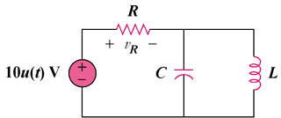

Figure 16.83
For Prob. 16.60.

Solution

Step 1. First convert the circuit into the s-domain. Then use nodal analysis and eventually solve for V_{R}, then perform a partial fraction expansion and convert back into the time domain.

10/s

+
−

2s

3 Ω
+ −

V_{R}

18/s

V₁

[(V₁-10/s)/3]+[(V₁-0)/(18/s)]+[(V₁-0)/(2s)] = 0 and V_{R} = (10/s)-V₁.

Step2. [(1/3)+(s/18)+1/(2s)]V₁ = 3.333/s = [(s²+6s+9)/(18s)]V₁ or
V₁ = 60/[(s+3)²] and V_{R} = (10/s)-60/[(s+3)²].

Thus,
v_{R}(t) = [10-60te^{-3t}]u(t) volts.

